Student Name : Jervis Chan Jun Yong_____________

Group : TS8___________________________

Date : 7 April 2021_____________________

LAB 4: ANALZING NETWORK DATA LOG

You are provided with the data file, in .csv format, in the working directory. Write the program to extract the following informations.

Exercise 4A: TOp TALKERS and LISTENERS

One of the most commonly used function in analyzing data log is finding out the IP address of the hosts that send out large amount of packet and hosts that receive large number of packets, usually know as TOP TALKERS and LISTENERS. Based on the IP address we can obtained the organization who owns the IP address.

List the TOP 5 TALKERS

Rank | IP address | # of packets | Organisation
1 | 193.62.192.8 | 3041 | European Bioinformatics Institute
2 | 155.69.160.32 | 2975 | Nanyang Technological University
3 | 130.14.250.11 | 2604 | National Library of Medicine (NLM)
4 | 14.139.196.58 | 2452 | Indian Institute of Technology (IIT), Guwahati
5 | 140.112.8.139 | 2056 | Taiwan Academic Network, Ministry of Education computer Center

TOP 5 LISTENERS

Rank | IP address | # of packets | Organisation
1 | 103.37.198.100 | 3841 | A-STAR
2 | 137.132.228.15 | 3715 | National University of Singapore
3 | 202.21.159.244 | 2446 | Republic Polytechnic
4 | 192.101.107.153 | 2368 | Pacific Northwest National Laboratory (PNNL-Z)
5 | 103.21.126.2 | 2056 | Indian Institute of Technology Bombay

Exercise 4B: TRANSPORT PROTOCOL

Using the IP protocol type attribute, determine the percentage of TCP and UDP protocol

 | Header value | Transport layer protocol | # of packets
1 | 6 | TCP | 56064 (82.37%)
2 | 17 | UDP | 9462 (13.90%)
 |  | All Protocols | 68065

Exercise 4C: ApplicationS PROTOCOL

Using the Destination IP port number determine the most frequently used application protocol.
(For finding the service given the port number https://www.adminsub.net/tcp-udp-port-finder/ )

Rank | Destination IP port number | # of packets | Service
1 | 443 | 13423 | HTTPS
2 | 80 | 2647 | HTTP
3 | 52866 | 2068 | Dynamic Port and/or Private Ports  Xsan. Xsan Filesystem Access (Apple)
4 | 45512 | 1356 | Unassigned Port
5 | 56152 | 1341 | Dynamic Port and/or Private Ports  Xsan. Xsan Filesystem Access (Apple)

Exercise 4D: Traffic

The traffic intensity is an important parameter that a network engineer needs to monitor closely to determine if there is congestion. You would use the IP packet size to calculate the estimated total traffic over the monitored period of 15 seconds. (Assume the sampling rate is 1 in 1000)

Total Traffic( MB) | Assuming sampling rate of 1 in 1000  64777.822MB (base10 MB to B conversion)  61776.945 (base2 MB to B conversion)

Exercise 4E: ADDITIONAL ANALYSIS

Exercise 4E(a): Top 5 communication pairs

pair_a | a_org | pair_b | b_org | count
137.132.228.15 | National University of Singapore | 193.62.192.8 | Janet University Network | 4951
103.37.198.100 | A-STAR | 130.14.250.11 | National Library of Medicine | 2842
14.139.196.58 | NKN EDGE Network | 192.101.107.153 | ESnet | 2368
103.21.126.2 | Indian Institute of Technology Bombay | 140.112.8.139 | National Taiwan University | 2056
140.90.101.61 | Noaa-silverspring | 167.205.52.8 | Institute of Technology Bandung | 1752

Exercise 4E(B): visualisation of top Talker/listener communications
Out of curiosity, I would love to know the kind of communications of the top 5 listeners and top 5 talkers. Are they exclusively communicating with one IP? Or are they communicating with many different IPs?

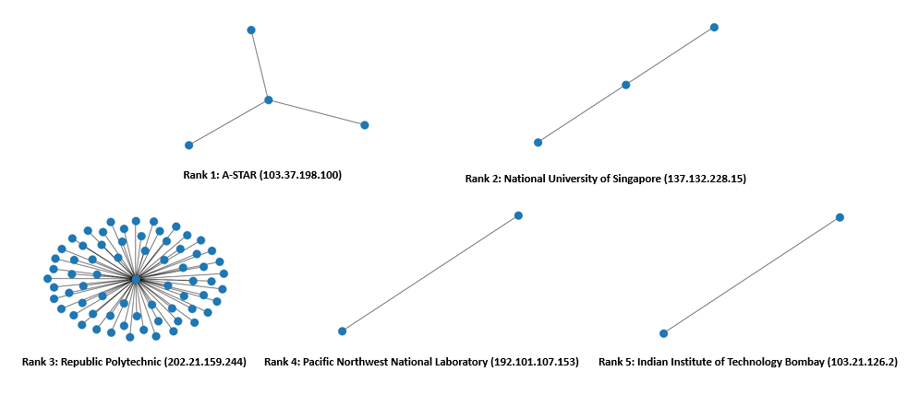Figure 1: Visualisation of Top 5 Listeners

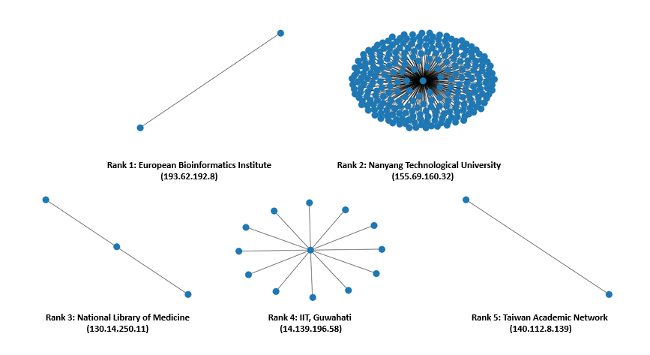
Figure 2: Visualisation of Top 5 Talkers
After visualizing, it could be more likely that the data scope is limited, leading to more data from NTU.

Exercise 4F: SOFTWARE CODE
